IDEATION PHASE
Brainstorming and Idea Generation
Date | 20 Feb 2026
Team id | LTVIP2026TMIDS46782
Project Name | Streamlining Ticket Assignment for efficient support operations
Maximum Marks | 4
Brainstorming and Idea Generation:
During the brainstorming phase, the team analysed common challenges in customer support systems such as manual ticket routing, uneven workload distribution, and delayed responses. Ideas were generated through group discussions, flow analysis, and comparison with existing helpdesk systems.
Some of the initial ideas included automating ticket classification, implementing Al-based routing, and creating a centralized dashboard for tracking progress. The team explored multiple approaches like keyword-based ticket sorting, priority tagging, and skill-based agent assignment to improve efficiency.
After evaluating all possibilities, the best idea was to develop an automated ticket assignment system that uses predefined rules or machine learning algorithms to route tickets to the most appropriate support agent. This system aims to reduce response time, enhance accuracy, and improve customer satisfaction while allowing managers to monitor performance through real-time analytics.
Key Ideas Generated:
- Al/Rule-based ticket categorization and routing.
- Real-time ticket tracking dashboard.
- Automated priority setting (urgent, high, medium, low).
- Balanced workload distribution among agents.
- Ticket status notifications for customers.
- Analytics for agent performance and response time. Ideal testing:
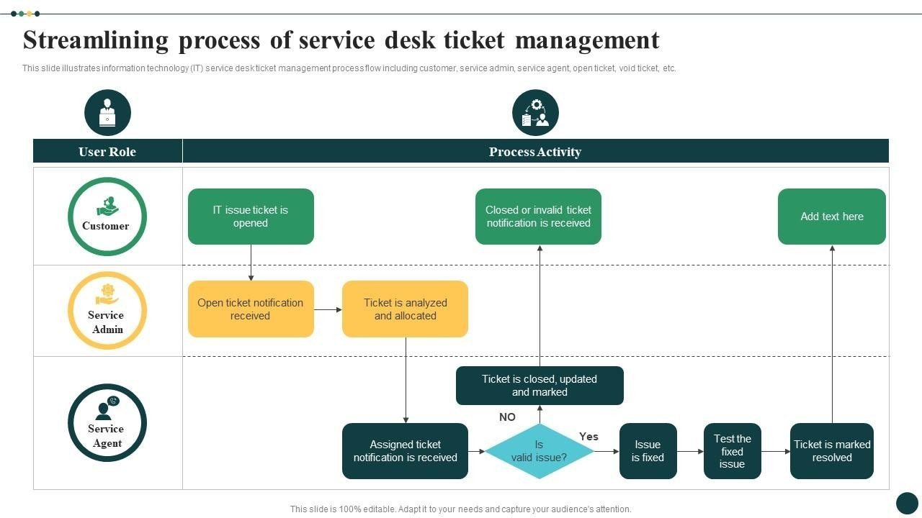
The project "Streamlining Ticket Assignment for Efficient Support Operations" focuses on enhancing the efficiency of IT support processes by automating and optimizing ticket assignment. Manual ticket allocation often causes delays, uneven workload distribution, and decreased customer satisfaction. This project aims to eliminate these issues through an automated system that categorizes and assigns tickets based on agent skill, workload, and priority. By integrating realtime tracking and analytics, the solution ensures faster response times, balanced workloads, and improved transparency. Ultimately, it enhances customer satisfaction and operational performance while reducing manual intervention and handling time.

